Assignment 1

### 1. Display a list of all data contained in the BOOKS table.

### 2. List the title only of all books available in inventory, using the BOOKS table.

### 3. List the title and publication date for each book in the BOOKS table. Use the column

### heading “Publication Date” for the Pubdate field.

### Graphical user interface, text, application, email Description automatically generated4. List the customer number for each customer in the CUSTOMERS table, along with the city

### and the state in which the customer lives.

### 5. Create a list containing the publisher’s name, the person usually contacted, and the

### publisher’s telephone number. Rename the contact column “Contact Person” in the

### displayed results. (Hint: Use the PUBLISHER table.)

### 6. Determine which categories are represented in the current book inventory. List each

### category only once.

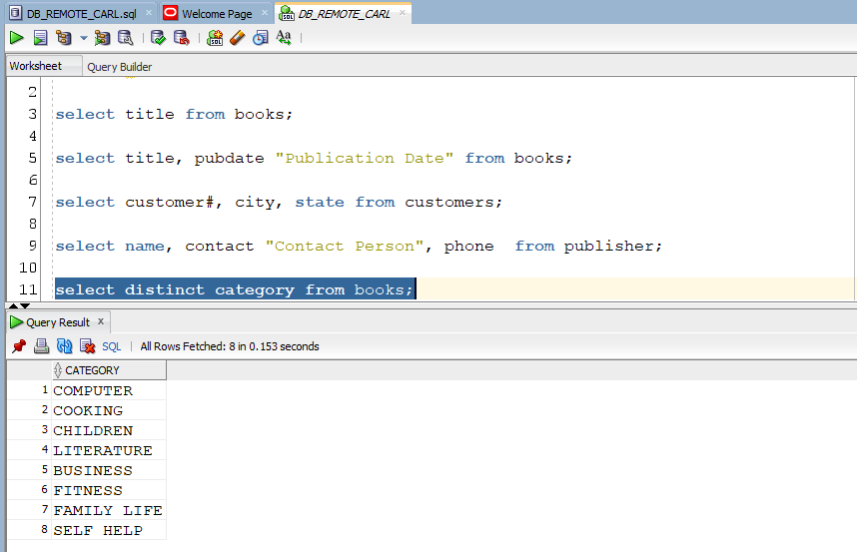

### Graphical user interface, text, application Description automatically generated7. List the customer number from the ORDERS table for each customer who has placed an

### order with the bookstore. List each customer number only once.

### 8. Create a list of each book title stored in the BOOKS table and the category in which each book belongs. Reverse the sequence of the columns so that the category of each book is listed first.

### 9. Create a list of authors that displays the last name followed by the first name for each author. The last names and first names should be separated by a comma and a blank

### space.

### Graphical user interface, application, table Description automatically generated10. List all information for each order item. Include an item total, which can be calculated by multiplying the Quantity and Paideach columns. Use a column alias for the calculated value to show the heading “Item Total” in the output.